AIN SHAMS UNIVERSITY
FACULTY OF ENGINEERING
Computer Vision Lab Assignment 01
OpenCV Image Processing
CSE480 / CSE482 Lab
Mechatronics Engineering and Automation Program
Prepared by
Student Name: _______________Kerolus Hany Rabie Hana ___________________
Student ID: ________________22P0134____________________
Fall 2026

1. Introduction
This report presents four image-processing tasks completed with Python, OpenCV, and NumPy. The tasks demonstrate selective colour isolation, weighted image blending, vignette filtering, and channel swapping. Each section states the objective, explains the processing steps, includes the code, and presents the resulting images.

2. Tasks and Workflow
The supplied apple, cameraman, zebra, and Mars rover images are loaded in OpenCV's BGR format. Each task writes its processed result to a results folder. The notebook uses cv2_imshow for inline display in Google Colab.

Common setup code
import cv2
import numpy as np
from pathlib import Path
from google.colab.patches import cv2_imshow
image_dir = Path(".")
output_dir = Path("results")
output_dir.mkdir(exist_ok=True)
def read_image(filename):
image = cv2.imread(str(image_dir / filename))
if image is None:
raise FileNotFoundError(f"Could not read {filename}")
return image

Task 1 Selective Colour Isolation

Objective
Keep red-dominant apple pixels in colour and convert the remaining image to grayscale.

Method and explanation
The image is converted to grayscale and split into blue, green, and red channels. A binary mask selects pixels where red is above 100 and exceeds both green and blue by more than 15. Bitwise operations combine the selected original pixels with the inverse-mask grayscale background.

Code
img = read_image("apple.png")
gray = cv2.cvtColor(img, cv2.COLOR_BGR2GRAY)
gray_bgr = cv2.cvtColor(gray, cv2.COLOR_GRAY2BGR)
b, g, r = cv2.split(img)
mask1 = cv2.threshold(r, 100, 255, cv2.THRESH_BINARY)[1]
mask2 = cv2.compare(r.astype(np.int16), g.astype(np.int16) + 15, cv2.CMP_GT)
mask3 = cv2.compare(r.astype(np.int16), b.astype(np.int16) + 15, cv2.CMP_GT)
mask = cv2.bitwise_and(cv2.bitwise_and(mask1, mask2), mask3)
red_apple = cv2.bitwise_and(img, img, mask=mask)
gray_background = cv2.bitwise_and(
gray_bgr, gray_bgr, mask=cv2.bitwise_not(mask)
)
result1 = cv2.add(red_apple, gray_background)
cv2.imwrite("results/task1_grayscale.png", gray_bgr)
cv2.imwrite("results/task1_mask.png", mask)
cv2.imwrite("results/task1_result.png", result1)
cv2_imshow(gray_bgr)
cv2_imshow(mask)
cv2_imshow(img)
cv2_imshow(result1)

Output
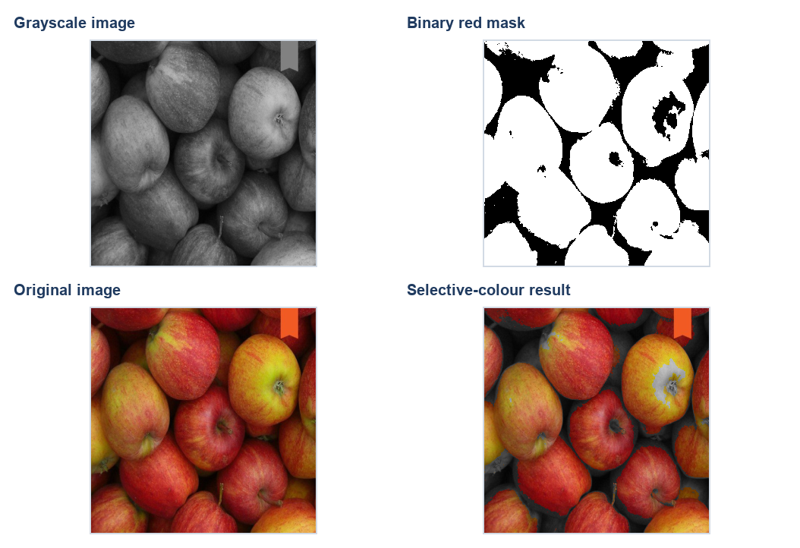
Figure 1. Grayscale image, red-dominance mask, original image, and selective-colour composite.

Task 2 Creating a Ghostly Overlay

Objective
Blend the cameraman and zebra images into a translucent composite.

Method and explanation
The zebra image is resized to match the cameraman dimensions. cv2.addWeighted() combines both images with equal 0.5 weights and zero brightness offset, so each source contributes equally.

Code
img1 = read_image("cameraman.jpg")
img2 = read_image("zebra.png")
img2 = cv2.resize(img2, (img1.shape[1], img1.shape[0]))
result2 = cv2.addWeighted(img1, 0.5, img2, 0.5, 0)
cv2.imwrite("results/task2_ghost.png", result2)
cv2_imshow(img1)
cv2_imshow(img2)
cv2_imshow(result2)

Output
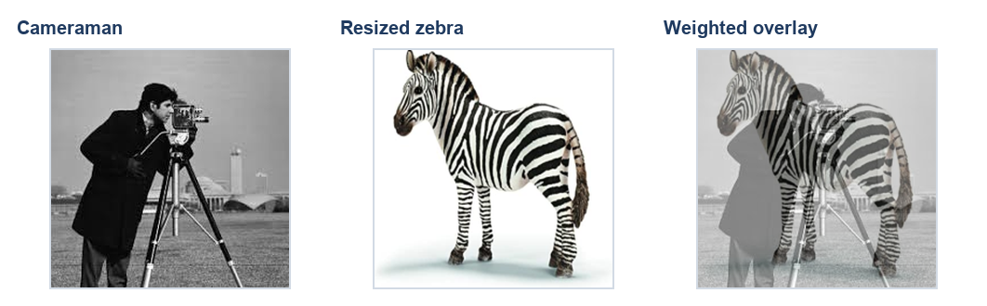
Figure 2. Source images and their equal-weight overlay.

Task 3 Artistic Vignette Filtering

Objective
Darken the outer edges gradually while preserving a brighter central region.

Method and explanation
A black mask is created and a filled white circle is drawn at the image centre. Gaussian blur softens the circular boundary. The mask is normalized to 0–1 and multiplied into the image, reducing brightness toward the edges.

Code
img = read_image("marsrover.png")
height, width = img.shape[:2]
mask = np.zeros((height, width), dtype=np.uint8)
center = (width // 2, height // 2)
radius = min(height, width) // 2
cv2.circle(mask, center, radius, 255, -1)
mask = cv2.GaussianBlur(mask, (101, 101), 50)
mask_float = mask.astype(np.float32) / 255.0
result3 = (img.astype(np.float32) * mask_float[:, :, None])
result3 = result3.clip(0, 255).astype(np.uint8)
cv2.imwrite("results/task3_mask.png", mask)
cv2.imwrite("results/task3_vignette.png", result3)
cv2_imshow(mask)
cv2_imshow(result3)

Output
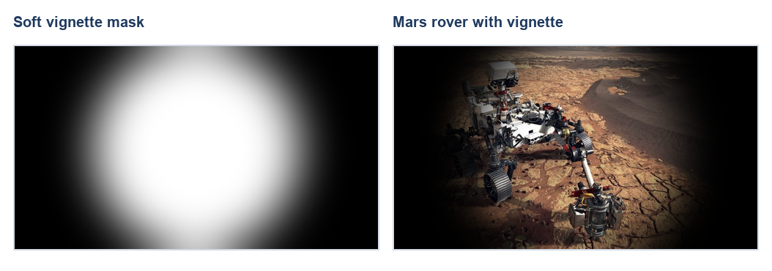
Figure 3. Soft vignette mask and Mars rover image after application.

Task 4 Channel Swapping

Objective
Produce a surreal palette by merging the zebra image channels in a different order.

Method and explanation
OpenCV stores colour images in BGR order. cv2.split() separates the channels and cv2.merge() recombines them as red, blue, green. This changes the represented colours while leaving pixel locations unchanged.

Code
img = read_image("zebra.png")
b, g, r = cv2.split(img)
result4 = cv2.merge([r, b, g])
cv2.imwrite("results/task4_channel_swap.png", result4)
cv2_imshow(img)
cv2_imshow(result4)

Output
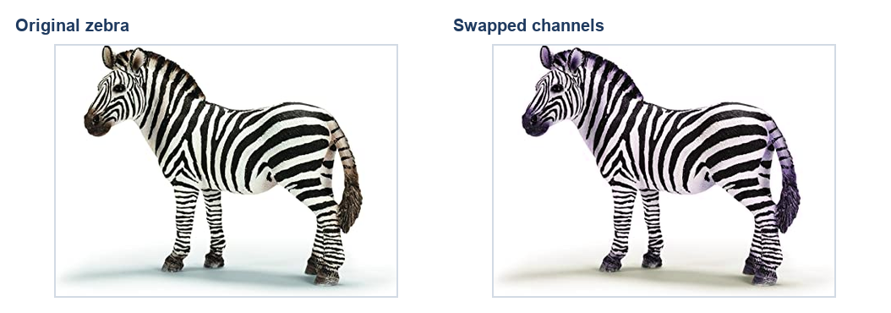
Figure 4. Original zebra and the channel-swapped result.

5. Conclusion
The four exercises show how masks, channel values, weighted arithmetic, and Gaussian blur can produce distinct image effects. The final images demonstrate selective colour, a translucent overlay, a soft vignette, and a surreal channel rearrangement.

References
CSE480/CSE482 Computer Vision Lab, Lab Assignment 01 task sheet, Ain Shams University Faculty of Engineering.
OpenCV documentation: https://docs.opencv.org/4.x/

